EXPLORE THE WORLD WITH SHEAFE’S FLAT BLUEBIRD
Due: Friday, May 11, 2012
STUDENT NAME: ____________________________________________________ ROOM ___________
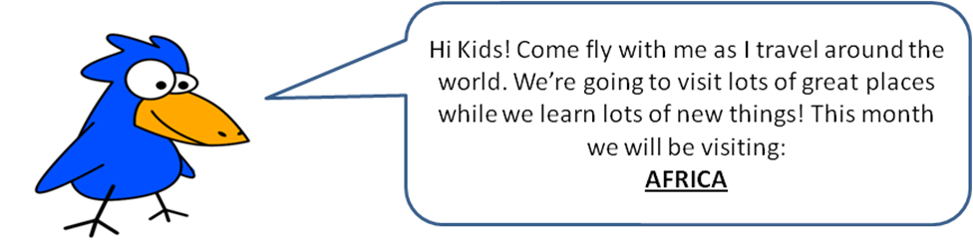
Hello Sheafe Road students! This week I’m heading south from the Sahara Desert. Eventually, I’ll fly all the way down to South Africa, but I’m making two stops along the way. First, I’m stopping at Mount Kilimanjaro. Mount Kilimanjaro is a dormant (that means it hasn’t erupted in a long time) volcano in the country of Tanzania. Tanzania is on the eastern coast of Africa. Mount Kilimanjaro is the highest mountain in Africa. The second stop I’m making is at Victoria Falls (a waterfall). Victoria Falls is known as “the greatest known curtain of falling water.” It is located on the Zambezi River between the countries of Zambia and Zimbabwe. Once I leave Victoria Falls, I’m flying straight to South Africa. South Africa is made up of many different people. The country has 11 official languages and many more unofficial ones. The people in South Africa love music, using song and dance to express many of their ideas. They are also very good in sports, especially rugby, cricket, golf and soccer.

Using the following information, color the flag of South Africa.
The flag appears to be a “Y” lying on its side. The inside of the “Y” is green. The “V” in the top of the “Y” (it looks like a triangle) is black, with a gold (yellow) border between it and the green “Y”. The top and bottom borders of the “Y” are white. The space above the top border is red and the space below the bottom border is blue.

Looking for more of a challenge?
Turn the page over!

Mount Kilimanjaro is 19,340 feet high. Even though it sits almost on the equator, it is so tall that glaciers form at its top. Each year, about 15,000 people try to reach the top of the mountain but only about 6,000 – 7,000 actually reach the top. There are several routes a climber can use to climb Kilimanjaro. They are the Machame, Marangu, Lemosho, Northern Circuit, Rongai and Umbwe routes. One of the problems that the climbers face is that they need to get used to the climate as they climb Kilimanjaro. The word acclimatize means to adapt to a new environment or climate. Following is a summary of each of the routes. After reading the summaries, put the routes in order by mileage (longest route to shortest route).

Machame: best success rate; great for acclimatization; popular trail, therefore it can be crowded; challenging trek; 49 km

Lemosho: high success rate; very scenic; remote, therefore it is less crowded; 56 km

Umbwe: shortest, but steepest route; requires physical endurance; bad for acclimatization; 37 km

Northern Circuit: newest route to Kilimanjaro; long route with great views; very low traffic due to long time on the mountain; 90 km

Rongai: only northern approach to Kilimanjaro; least scenic; good for acclimatization; 65 km

Marangu: very popular route, therefore it is crowded; beautiful forests; good for acclimatization;
64 km

ROUTE DISTANCE

